The Future of the Training Department
Posted 2009-10-21; filed under Informal Learning, Performance Improvement.
The latter 20th Century was the golden era of the training department. Before the 20th Century, training per se did not exist outside the special needs of the church and the military. Now the training department may be at the end of its life cycle. Join us for a brief look back at the pre-training world and some thoughts about what may lay ahead.
Before industrialization, work was local or industry meant cottage-industry. People had vocations, not jobs. Sometimes guilds helped apprentices learn by doing things under the eye of a master, but there weren’t any trainers involved.
About three hundred years ago, work became an organizational matter. Factories required groups of people working together. To coordinate their activities, groups need a shared understanding of who is doing what. Orders from the top of the organization kept everyone on the same page. Managers showed workers how to do things and made sure they were doing them the right way. A little training went on, but there still weren’t any trainers.
Fast forward to the 20th century. The pace of progress is unrelenting. Clocks measure working hours instead of the sun. Railroads and communications links span the globe. Competition fuels change. Efficiency becomes paramount. Frederick Taylor uses time-and-motion studies to find the one best way to do individual pieces of work. Taylor’s Principles of Scientific Management becomes the bible in the crusade for maximizing efficiency.
Training was invented in the first half of the 20th Century. GE started its corporate schools. NCR delivered the first sales training. Factory schools appeared in Europe. Mayo discovered the Hawthorne Effect, opening the study of motivation. B.F. Skinner constructed teaching machines. The U.S. military formalized instruction to train millions of soldiers for World War II. ASTD is born.
The second half of the 20th Century was arguably the Golden Age of Training. Every corporation worth its salt opened a training department. Xerox Learning, DDI, Forum Corporation, and hundreds of other “instructional systems companies” sprung up. Thousands upon thousands of trainers attended conferences to learn about new approaches like programmed instruction, behavior modification, role play, certification, CD-ROM, sensitivity training, corporate universities, and the Learning Organization. Training was good; efficient training was better.
Most of this training activity assumed that you could prepare people for the future by training them in what had worked in the past. Yesterday’s best practices were the appropriate prescription for curing tomorrow’s ills. That works when the world is stable, and things remain the same over time.
At this point in the 21st Century, the game is changing once again. Complexity, or maybe our appreciation of it, has rendered the world unpredictable, so the orientation of learning is shifting from past (efficiency, best practice) to future (creative response, innovation). Workplace learning is morphing from blocks of training followed by working to a merger of work and learning: they are becoming the same thing. Change is continuous, so learning must be continuous.
To justify its existence from here on, a training department must shift direction in three areas:
- Embracing complexity and adaptation to uncertainty
- Inverting the structural pyramid
- Adopting new models of learning

Embracing complexity
Nothing is for sure any more. Consultant and management theorist Dave Snowden has come up with a framework for management practice in complex environments.
Snowden’s Cynefin framework has been used in the study of management practice. It can also help us make decisions for our organizations. Understanding what type of environment we are working in (Simple, Complicated, Complex or Chaotic) lets us frame our actions. When the environment is complex: the relationship between cause and effect can only be perceived in retrospect, but not in advance, the approach is to Probe – Sense – Respond and we can sense emergent practice.
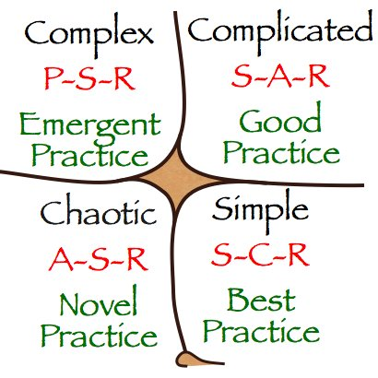
From the Cynefin perspective best practices are only suitable for simple environments and good practices are inadequate in responding to constant change. Both approaches look to the past for inspiration, or as Marshall McLuhan wrote, “We look at the present through a rear-view mirror. We march backwards into the future.”
Most of our environments are complex so first we need to probe, or take action, and then sense the results of our actions (Probe-Sense-Respond). This approach has already been adopted by Web services, where Beta releases are launched and tested before they are finalized. For example, Google’s ubiquitous GMail service is still in Beta. The phrase, “we are living in a beta world” is increasingly being used outside the Web services domain.
In complex environments it no longer works to sit back and see what will happen. By the time we realize what’s happening, it will be too late to take action. Here are some practical examples for learning professionals:
PROBE: Prototype; Field test; Accept Life in Beta; Welcome small failures
SENSE: Listen; Enable conversations; Look for patterns; Learn together
RESPOND: Support the work; Connect people; Share experiences; Develop tools

Inverting the Pyramid
So what models will work for our complex environments? The hierarchical organizational pyramid is a model that has worked for centuries. It’s premised on the beliefs that management has access to the necessary strategic information and knowledge. Because knowledge is thought to be power, management best understands the outside world and can clearly tell the workers what needs to be done and how.
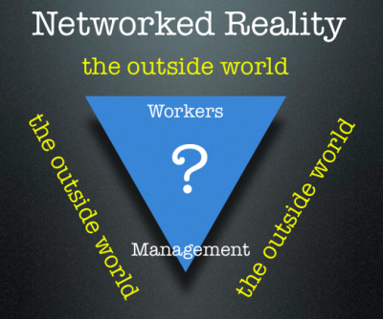
In a complex, networked environment the lines of communication are no longer clear and the walls between the workers and the outside world are porous. Many workers know more about the outside environment than management does. Today, the relationship between workers and management is not as clear as it once may have been. Effective organizations are starting to look more like inverted pyramids.
As the Cluetrain Manifesto succinctly stated almost a decade ago, “Hyperlinks subvert hierarchies”. Hierarchies may not die in the future but they may have to co-exist with a new form of workplace organization, the Wirearchy.
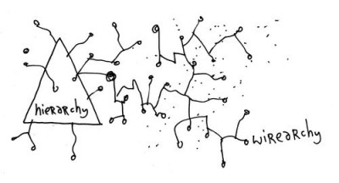
Researcher and analyst, Jon Husband, says that wirearchy is, “a dynamic two-way flow of power and authority based on information, knowledge, trust and credibility, enabled by interconnected people and technology”. The Internet has created interconnectedness on a massive scale. Power and authority must now flow two ways for any organization to be effective. This requires information, knowledge, trust and credibility. Wirearchy in action is evident in open source software development projects, with minimal command and control, yet able to compete directly with large hierarchical corporations.

A New Model for Training
Workers at the the bottom of the traditional organizational pyramid are those who interact closest with their environment (market, customers, information). To be effective today they need to be constantly probing and trying out better ways of work. Management’s job is to assist this dynamic flow of sense-making and to respond to workers’ needs, within a trusted network of information and knowledge sharing.
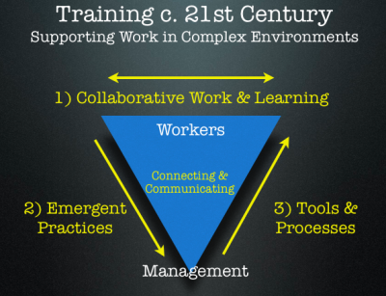
The main objective of the new training department is to enable knowledge to flow in the organization. The primary function of learning professionals within this new work model is connecting and communicating, based on three core processes:
1.Facilitating collaborative work and learning amongst workers, especially as peers.
2.Sensing patterns and helping to develop emergent work and learning practices.
3.Working with management to fund and develop appropriate tools and processes for workers.
The only certainty about the future from here on out is that it won’t resemble the past. For example, instructional designers no longer have time to develop formal courses. Survival requires people who can navigate a rapidly-changing maze at high speed. They need to find their own curriculum, figure out an appropriate way to learn it, and get on with it. It’s cliché to say that people have to learn how to learn. Management needs to support self-learning, not direct it.
Workers will also have to be their own instructional designers, selecting the best methods of learning. Furthermore, given the increasingly reciprocal nature of knowledge work, they will have to know how to teach. Each one-teach-one is at the heart of invent-as-you-go learning. The training department should be encouraging and supporting these activities.

Next?
Will training departments survive to address these issues? The cards are still out. After all, we are in a global economic depression, and training is the perennial first sacrifice.
What would happen if you called for closing your training department in favor of a new function?
Imagine telling senior management that you were shuttering the classrooms in favor of peer-to-peer learning. You’re redeploying training staff as mentors, coaches, and facilitators who work on improving core business processes, strengthening relationships with customers, and cutting costs. You’re going to shift the focus to creativity, innovation, and helping people perform better, faster, cheaper.
You might want to give it a try.
Perhaps the time has come.
Note: This article is a re-post of the original co-authored with my colleague Jay Cross (1944-2015)

Related Posts
- New Website Soon
- Friday's complexity

22 Responses to “The Future of the Training Department”
- Donald ClarkOctober 21st, 2009
Loved this. One extra – training received a huge boost during first and second world wars where arms and ammunition factories needed huge numbers of trained workers quickly.
Close the training departments – love it!
- Leandro CodarinOctober 21st, 2009
Hi Harold,
I share your opinion about the vision of training in relation to the needs of the environment. But one question, how to involve the workers themselves in the construction of knowledge?
In some cases managers are not close to reality to see how their knowledge or require their employees. In times of crisis, at least in Spain and Latin America, small businesses become more conservative.
So I think that workers themselves must appropriate tools to collaborate in developing their skills. Now, how to perform this process in an organization that relies on innovation?
- Simon BostockOctober 21st, 2009
I loved this post. And I think a focus on the flow of knowledge is crucial.
It’s interesting that you mention Dave Snowden. His post on defining Knowledge Management (http://www.cognitive-edge.com/blogs/dave/2009/09/defining_km.php) is in many ways similar in tone to your post. Here’s a comment I made on that post:
“…it’s a good definition.
But, only half in jest, I’ve put a tweaked version below. (I’ve changed four words and phrases from KM to Training etc).
The purpose of the Training Department is to provide support for improved decision making and innovation throughout the organization. This is achieved through the effective management of human intuition and experience augmented by the provision of information, processes and technology together with Knowledge Management programmes.
The following guiding principles will be applied:
All courses will be clearly linked to operational and strategic goals
As far as possible the approach adopted will be to stimulate local activity rather than impose central solutions
Co-ordination and distribution of learning will focus on allowing adaptation of good practice to the local context
Management of the L & D function will be based on a small centralized core, with a wider distributed network”
Is Learning & Development entering into a turf war with Knowledge Management?
  - Harold JarcheOctober 21st, 2009
@Donald said only half in jest!
@Leandro if you need to innovate, you can’t rely on management to clear the path. Dealing with complex problems requires faster feedback loops, which goes against hierarchies & control. To misquote an old socialist, “Knowledge workers of the world, Collaborate! You have nothing to lose but your Managers”
@Simon I think that L&D, KM, OD, HR, IT, etc. had better learn how to integrate and play well together or they may all become redundant.
- Jon HusbandOctober 22nd, 2009
@Simon I think that L&D, KM, OD, HR, IT, etc. had better learn how to integrate and play well together or they may all become redundant.
I was going to say “bingo”, but hmmm … redundant ? Relatively ineffectual, maybe. I don’t see HR and IT becoming redundant, though I am pretty sure I know where you are coming from.
It’s clear to me, though, that all of these more-or-less siloed areas have, in an interconnected environment and focused on enabling effective work, massive incentive to integrate and / or collaborate closely on what they do and deliver.
- Annette KramerOctober 30th, 2009
Hi,
Great post — very well articulated.
However, I sitll have an issue with the distinction between “training” and “learning” — I think we should think of workers (eg all of us) as learners. If we referred to ourselves that way, there wouldn’t be any question that the process needs to continue, be varied, cross contexts and disciplines, and look to innovate.
I’ve banged on about this too much in my blog already — Training to me is learning to consider particular tasks or thinking within a very limited context. What do you think of changing the word?
Best,
Annette
- Harold JarcheOctober 30th, 2009
Thanks for the comment, Annette. There’s no doubt we’re all learners. Training is something that is externally directed while learning is an internal process. Here’s how I see some of the distinctions:
http://jarche.com/2007/11/putting-a-training-peg-into-an-education-hole/
- Michael ForrestNovember 4th, 2009
This article really requires detailed analysing.
With many good and not-so-good Training Departments there is an absolute need to provide assitance to the”flexible” worker. Management needs to recognise the tools that are required to devlop required skills and provide them in a timely manner which will be difficult in an unstructure world going forward.
It will be similar to an athlete running in a distance race where tactics are the difference between winning and finishing behind the winner. Will winning be the ultimate or will it be “keeping up”
No doubt we are entering interesting times.
Let’s hope integrity wins over those who will be prepared to cut corners!
- Stephen J. GillDecember 14th, 2009
As the great architect Louis Sullivan said, “Form ever follows function.” So for me the question is, “What is the best structure for facilitating learning that will result in achieving business goals?” That necessitates what Sean Murray and I call the “5As Framework”: 1) alignment of learning interventions (training, coaching, online support, etc.) with goals; 2) anticipating success; 3) learning alliance of learner with supervisor/boss; 4) application of learning to achieve business goals; and 5) accountability for business results. Whatever structure (centralized training department; distributed training department; collaborative networks; etc.) supports these elements, that is what is needed.

Leave a Reply

- 



 Notify me when new comments are added.



Connect with Harold
Contact Information

Starts 20 September
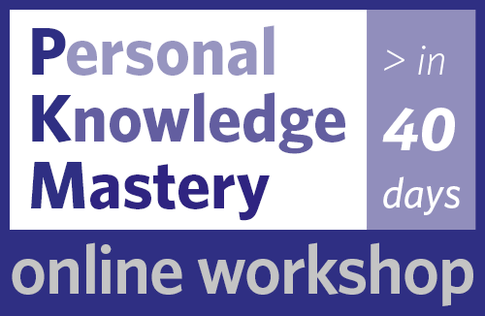

e-book series


Our Community of Practice


Subscribe by email
(Un)Subscribe to Posts

Recent Posts
- convening the right people
- filtering out the crap
- a labour of love
- the last fortnight
- the social sweet spot
- social learning powers distributed work
- we have met the enemy
- top tools 2021
- learning with others
- making meaning

Browse by Topic

Browse by Topic

Archives
Archives 

Recent Conversations
- Opportunities and Challenges Associated with Networked Workers – Leadership Dialogue in Changing Times on embracing automation
- Opportunities and Challenges Associated with Networked Workers – Leadership Dialogue in Changing Times on networks are the new companies
- An inevitable evolution – Dan’s Blog on networks are the new companies
- Opportunities & Challenges of the Higher Ed Networked World – Leadership & Technology Discussion on The Networked Workplace
- Opportunities & Challenges of the Higher Ed Networked World – Leadership & Technology Discussion on embracing automation
- Life Kuration - Lernen lernen #CLC21 - LernXP: LernXplorer Blog on The Seek > Sense > Share Framework
- Russell Stanton on Knowledge filters
- Would you like to collectively try my explicit, experiential knowledge? – Dan’s ILD831 Blog on closing the learning-knowledge loop
- Week 3: Knowledge Management – Creighton Doctoral Student and 5th Grade Teacher on knowledge-sharing paradox redux
- KM in the Digital World – Leadership & Technology Discussion on closing the learning-knowledge loop
This work by Harold Jarche is licensed under Attribution-NonCommercial-ShareAlike 4.0 International (CC BY-NC-SA 4.0). jarche.com is powered by Tantramar Interactive Inc.

